

**Artefact Classification**

**Royal Heritage Museum, Trongsa**

**Museum Division,**

**Department of Culture and Dzongkha Development,**

**Ministry of Home Affairs**

1. **Classification of Museum Artefacts**

The rich cultural heritage of Bhutan, preserved in its museums, requires a systematic and standardized approach to artifact classification to enhance collection management, research, and accessibility. While Bhutanese museums—such as the National Museum in Paro, the Royal Heritage Museum in Trongsa, and the Textile Museum in Thimphu—have made significant efforts in cataloging their collections, a unified classification system is still needed to ensure consistency, interoperability, and future acquisitions.

This study proposes a structured classification framework consisting of seven major categories and fifty-nine subgroups, designed to encompass all existing and potential artifacts in Bhutanese museums. This classification draws upon international standards, while incorporating locally relevant categories that reflect Bhutanese religious, artistic, and utilitarian traditions. By analyzing existing classification methods used in Bhutan and globally, this model aims to establish a controlled vocabulary, logical hierarchy, and scalable structure adaptable to digital cataloging systems.

The proposed classification addresses key challenges, including terminology, cultural contextualization, and integration with existing museum databases. Its implementation would facilitate better artifact documentation, exhibition planning, and cross-institutional collaboration.

Before driving into new classification, let's look into existing classification methods used by the museums around the world. For better understanding, i have studied some common classification methods used by museums globally:

### **1. By Material/Medium**

Many museums categorize artefacts based on the material they are made of:

**Ceramics & Pottery** (ancient Greek vases, Chinese porcelain)

**Metals** (bronze sculptures, gold jewelry, iron tools)

**Stone** (marble statues, inscribed stelae)

**Textiles** (tapestries, clothing, carpets)

**Wood** ( furniture, carvings)

**Glass** ( Roman glassware, stained glass)

**Organic Materials** ( ivory, bone, leather)

**Composite Objects** (made of multiple materials)

### **2. By Function/Use**

Artefacts are often grouped by their original purpose:

**Domestic Items** (utensils, furniture, cooking tools)

**Religious & Ritual Objects** (idols, amulets, ceremonial vessels)

**Weapons & Armor** (swords, shields, guns)

**Tools & Implements** (agricultural, craft-making tools)

**Artistic Works** (paintings, sculptures, decorative arts)

**Currency & Trade Goods** (coins, weights, seals)

**Clothing & Adornments** (jewelry, garments, accessories)

### **3. By Cultural/Historical Period**

Museums often classify artefacts based on time periods:

**Prehistoric** (Paleolithic, Neolithic artefacts)

**Ancient Civilizations** (Egyptian, Mesopotamian, Greek, Roman)

**Medieval** (Byzantine, Islamic, European feudal artefacts)

**Early Modern** (Renaissance, Colonial-era objects)

**Modern & Contemporary** (20th–21st century items)

### **4. By Geographic Origin**

Artefacts are frequently organized by their place of discovery or cultural origin:

**Africa** (Egyptian, Sub-Saharan, Berber artefacts)

**Asia** (Chinese, Indian, Japanese, Mesopotamian)

**Europe** (Celtic, Viking, Renaissance)

**Americas** (Pre-Columbian, Native American, Colonial)

**Oceania** (Aboriginal, Polynesian, Maori)

### **5. By Museum-Specific Classification Systems**

Some major museums use specialized taxonomies:

**The British Museum (London)** – Uses a mix of material, period, and cultural classifications.

**The Louvre (Paris)** – Departments like "Egyptian Antiquities," "Greek & Roman," "Decorative Arts."

**The Smithsonian (USA)** – Follows thematic divisions (e.g., "American History," "Natural History").

**The Hermitage (Russia)** – Classifies by era and region (e.g., "Scythian Gold," "European Paintings").

### 6. Digital & Universal Classification Systems

Many museums now use standardized systems for cataloging: **ICOM (International Council of Museums)** guidelines, **CIDOC-CRM** (Conceptual Reference Model for artefact documentation) and **AAT (Art & Architecture Thesaurus)** used for consistent terminology.

1. **Current situation**

While museums worldwide have established websites, these platforms rarely serve as effective tools for guiding users—particularly researchers—to explore collection details in depth (Ménard, Mas, & Alberts, 2010). As Ménard et al. (2010) note, when artifact information is provided, it is often overly technical or inaccessible. For Bhutanese museums venturing into digitization, this presents a critical cautionary lesson. As the Museums Division implements a digital management system to enhance artifact documentation and accessibility, early stages have revealed inconsistencies in classification methods across institutions. These discrepancies hinder unified searchability, research, and public engagement.

The proposed classification system aims to address these challenges by standardizing terminology and structure, ensuring that artifacts—whether religious, historical, or cultural—are cataloged consistently. While no system can fully satisfy every curator or enthusiast, this framework provides a clear, practical foundation for museums to upload collections systematically. By prioritizing intuitive organization and avoiding jargon, it seeks to make Bhutan’s heritage more accessible to scholars, educators, and the public alike.

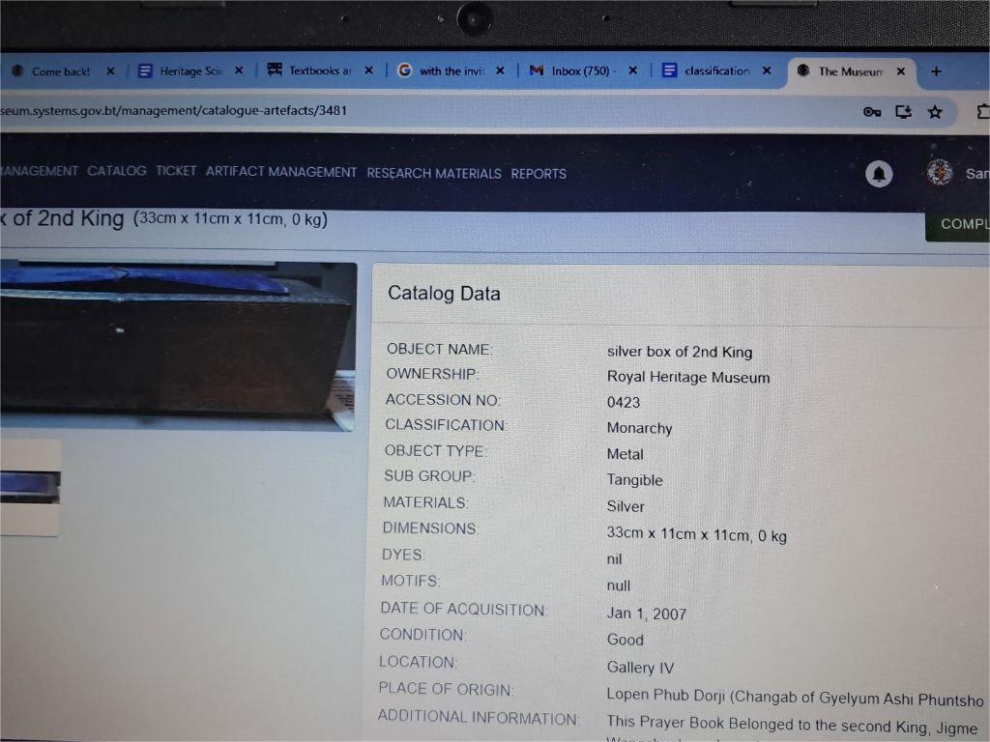

Figure: 1 CMS in use by museums under musuem division

1. **Propose for general artefact classification for museums under museum division.**

Significant work remains to be done in improving museum collection management across Bhutan. This crucial task requires a coordinated effort among Bhutanese curators to systematically classify the extensive artifacts housed in our national museums.

After careful study of international classification systems and existing practices at Bhutan's premier institutions - including the National Museum in Paro, the Royal Heritage Museum in Trongsa, and the Textile Museum in Thimphu - I have developed a comprehensive new classification system. This framework addresses current inconsistencies through:

1. A clear logical structure
2. Standardized controlled vocabulary
3. Seven major categories
4. Fifty-nine subgroups

The system has been designed to encompass not only current collections but also potential future acquisitions, providing Bhutan's museums with a robust, future-proof classification standard. This work builds upon both global best practices and local Bhutanese museum expertise to create a solution tailored to our nation's unique cultural heritage.

|  |  |  |  |  |
| --- | --- | --- | --- | --- |
| **Majorgroup** | **Subgroup** | **Object Name** | **Materials** | **Descriptions** |
| Household Items | Furniture  Kitchenwares  Musical instruments  Equipment  Decorative items  Thakshing/Weaving Equipment  Container |  |  |  |
| Religious and Ritual Items | KU/Stautes  Sung  Thug  Yoenten (qualities)  Thinley (Activities)  Masks  Dance Costums  Tonde |  |  |  |
| Clothing and Ornament | Gho  Kira  Kera  Rachhu  Kabney  Tego  Pangkheb  Lham/shoe  Wongju  Gutsuma  Head ornaments  Ear ornament  Neck Ornament  Nose Ornament  Hand and Arm Ornament  Waist Ornament  Foots ornament  Bag  Yathra  Merak Sakten Costume  Layab Costume  Kheb  Purse/ Pouch |  |  |  |
| Weapon and Armour | Head Gear  Chest Armor  Arms/Shoulder  Melee Weapon  Ranged Weapon |  |  |  |
| Numismatic items | Coin  Weight  Seal  Paper Note  Medal  Stamps  Almanac  Tsali |  |  |  |
| Zoological Specimen | Entomology(Insects)  Herpetology (Reptiles and amphibians )  Mammalogy (Mammals)  Ornithology (Bird) |  |  |  |
| Miscellaneous |  | Yeti's Palm  Peling Tooth  Dog Tooth  Elephant Tusk  Elephant Tooth |  |  |

****Conclusion****

Artifact classification in museums globally demonstrates considerable variation, though most systems organize collections by core attributes: material composition, functional purpose, historical period, and cultural provenance. While major institutions frequently employ hybrid classification models, contemporary digital practices emphasize standardized systems to enhance worldwide accessibility and interoperability.

Recognizing these global trends while addressing Bhutan's specific museological needs, the Museums Division has developed a unified classification framework. This system serves dual purposes:

1. Establishing consistent documentation standards across all Bhutanese museum
2. Ensuring compatibility with international digital heritage initiatives

By implementing this standardized approach, Bhutan positions its cultural collections for both enhanced local management and global scholarly engagement, while preserving the distinctive character of its national heritage.

Submitted by:

(Sangay Tashi)

Dy.Chief Curator/Head

RHM, Trongsa, 2025

References

Byrne, S. (2009). "A Critique of Unfeeling Heritage." *In *Heritage and Globalization* (pp. 229-240). Routledge.

Chenhall, R. G. (1978). *Nomenclature for Museum Cataloging: A System for Classifying Man-Made Objects*. American Association for State and Local History.

Hyvönen, E. (2012). "Publishing and Using Cultural Heritage Linked Data on the Semantic Web." *Synthesis Lectures on the Semantic Web*. Morgan & Claypool.

Ménard, E., Mas, S., & Alberts, I. (2010). Faceted classification for museum artefacts: A methodology to support web site development of large cultural organizations. *Aslib Proceedings: New Information Perspectives*, *62*(4/5), 523–532. <https://doi.org/10.1108/00012531011074753> 81217.

Srinivasan, R., et al. (2009). "Diverse Knowledges and Contact Zones within the Digital Museum." *Science, Technology, & Human Values*, 34(5), 735-768.

<https://www.google.com/search?q=artefacts+classification+in+musuems&oq=artefacts+classification+in+musuems&gs_lcrp=EgZjaHJvbWUyBggAEEUYOTIJCAEQIRgKGKABMgkIAhAhGAoYoAEyBwgDECEYnwUyBwgEECEYnwXSAQoxNDU4NGowajE1qAIIsAIB8QU7NKL4rq4_iA&sourceid=chrome&ie=UTF-8>

<https://mw2016.museumsandtheweb.com/paper/synthetic-classification-of-museum-artifacts-using-basic-concepts/index.html>